Digital Footprint
  - A beginner-friendly OSINT Challenge — TryHackMe

Task 1: The Leaked Photo
An ACME Jet Solutions employee uploaded a photo of a residential property believed to be linked to ACME Jet’s early operations. Can you figure out where the picture was taken to confirm or debunk the rumour?
Flag format: THM{City}
Question: In which city was the photo taken?
Investigation
- The photo was given as a Task File with this challenge.
- I started by looking at the Exif Data for this image and found some coordinates.
Latitude : 26 deg 12' 14.76"
Longitude : 28 deg 2' 50.28"
- We found the coordinates, but these don’t have any directional letters (N, S, E, W), so we need to try all four combinations and check where they lead us. We will use Google Maps for this.
- The four combinations will be:
26°12'14.76"N, 28°02'50.28"E
26°12'14.76"S, 28°02'50.28"E
26°12'14.76"N, 28°02'50.28"W
26°12'14.76"S, 28°02'50.28"W
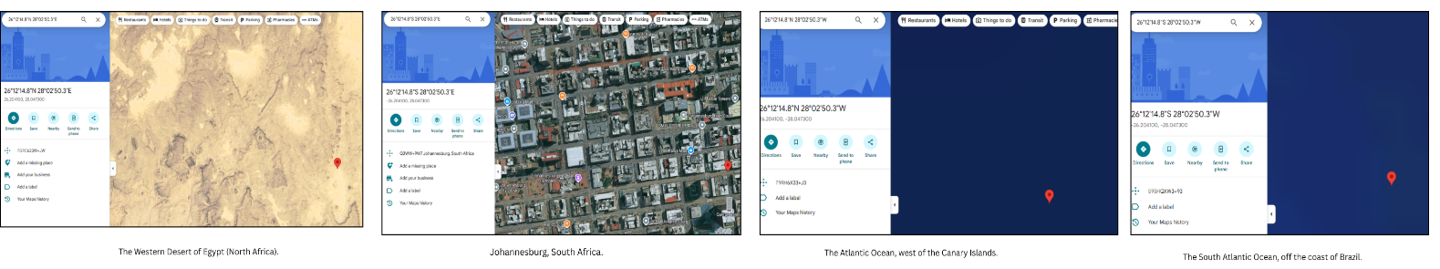
Only the second coordinate leads us to a proper city, Johannesburg, South Africa, confirming the origin of this photograph.
Final Answer
THM{Jo********rg}
Task 2: Archived Company Website
ACME Jet Solutions (warc-acme.com/jef/) is all over social media, claiming they were founded in 2025 and that they’re the fastest-growing data company in Africa. But something doesn’t add up; one of their ex-employees assures you that the company existed long before that.
Flag Format: THM{YYYYMMDDHHMMSS}
Question. When was the website first published on the internet?
Investigation Process
- The verbiage clearly states that an employee assumes that the company existed long before 2025. To confirm this, we can look for archived versions of this website using Archive.com.
Archive: https://archive.org/details/warc-acme.com-jef
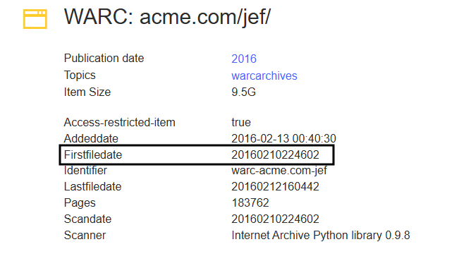
- The archive metadata revealed the first time the website appeared online.
Final Answer
THM{20160********2}
Task 3: Mysterious Landmark
Another image surfaced on the internet, which is believed to be connected to the company’s international expansion.
Research shows that:
- An iconic landmark is visible in the image.
- To the right of this iconic landmark is a building that played a big role in the fight for the independence of a particular country.
- The building name appears on its exterior wall.
Flag format: THM{Landmark}
Question: What is the landmark?
Investigation Process
- The image was given as a Task File with this challenge.
- Again, I started by analyzing the EXIF data for this image, which apparently revealed nothing of interest.
- So I moved to analyzing landmarks in the image. After playing with different filters, color, and brightness, I was able to clear the picture a bit, revealing two street banners on the left side of the image that read “Dublin,” indicating a potential connection to Dublin.
- To validate my theory, I started doing basic searches on Google by utilizing the intel gathered from data so far.
- On my very first Google search, I was able to find the name of this landmark, which is “The Spire” or “Spire of Dublin.”
Press enter or click to view image in full size
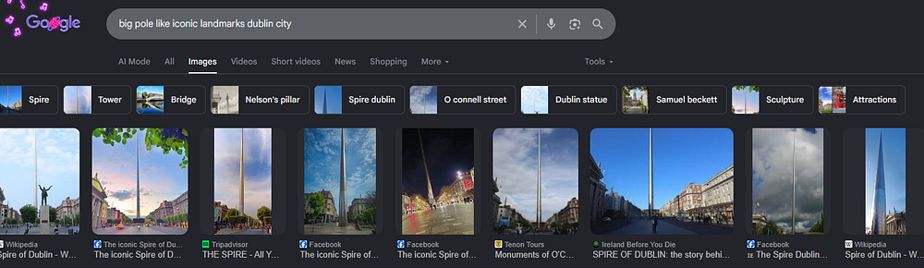
Now, we just need to build the right side of this Landmark. If you look at the Task image, there is an old reddish building left of the Spire of Dublin and in the same lane as those banners.
Press enter or click to view image in full size
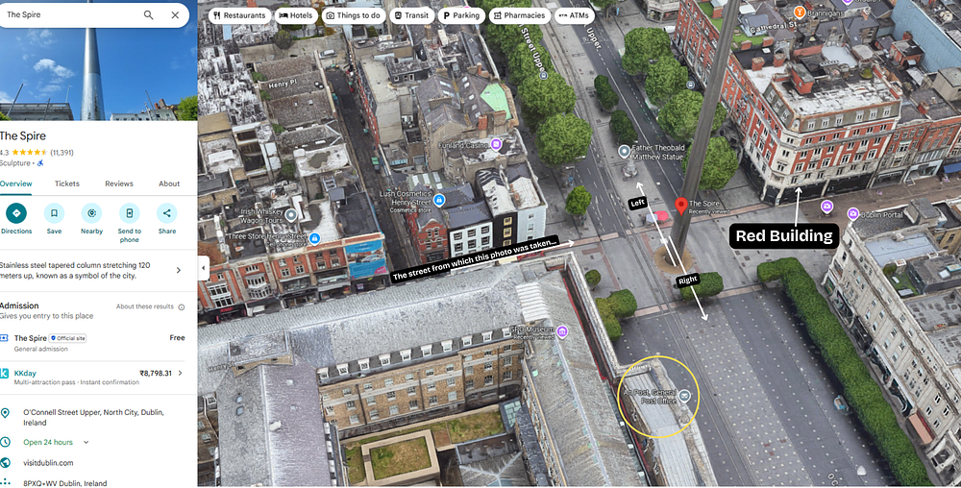
The first landmark on the right side of the Spire of Dublin on O’Connell Street is the “General Post Office”, which famously served as the rebel headquarters during the 1916 Easter Rising, making it the symbolic birthplace of the modern Irish Republic.
Final Answer
THM{G****************e}
Task 4: Internal Documents
Investigators believe that an internal document was accidentally leaked by one of the company’s developers. The document may contain crucial information about the individual responsible for maintaining their systems. The document was provided as part of the task.
Question: What is the final flag?
Investigation Process
- The leaked file had an .odt extension, which are essentially ZIP archives, so I renamed the file from .odt to .zip
- Upon extraction, it revealed multiple files and folders. So I started analyzing each one.
- meta.xml file has a username “markwilliams7243” tagged as an internal username.
- I’ve used Spiderfoot for gathering intel on this username. You can use any other tool if you like, such as Sherlock, MrHolmes, or online tools such as Whatsmyname.app.
- The results will reveal a YouTube channel registered in his name. Upon visiting the YouTube channel, there will be a post in which our last flag is present.
Final Answer
THM{Y********l4g!}
“Failure is simply the opportunity to begin again, this time more intelligently.” ~ Henry Ford
___________

